**School of Electrical and Electronic Engineering**



Embedded Systems Project

DESIGN REPORT #1

Title: ?

Group Number: 22

|  |  |  |
| --- | --- | --- |
| Group members name: | ID Number | I confirm that this is the group’s own work. |
| Abdullah Ahmed Akhtar | 10059854 |  |
| Aarambh Sinha | 10163290 |  |
| Osama Othman | 10135442 |  |
| Subhi Alsous |  |  |
| Marlon |  |  |

Tutor: Dr Zhirun Hu

Date: 02/11/2018

Contents

1. Introduction 1

2. Motor characterisation 2

2.1. Armature Resistance 2

2.2. Torque Constant 3

2.3. Back EMF Constant 3

3. Load measurements 5

4. Gear ratio selection 7

5. Summary 9

6. References 9

# Introduction

Aim of the project is to build an electronic buggy, which can autonomously follow a white line around a track consisting of sharp turns and slopes. For our buggy to go up the ramp, it will require more torque, therefore we need something which will change the torque and speed of the buggy, depending on the situation, e.g. moving up the ramp or on a flat surface. To achieve this our buggy requires a gearbox [1]. Using a gearbox has advantages but also some disadvantages:

**Advantages**: It can change the torque, depending on the load, on the motor, it can be used to increase and reduce the speed and it provides large variety of torque and speed with same input power.

**Disadvantages**: Results in lower overall efficiency due to additional components. E.g. energy lost due to friction between gear wheels, additional cost of a gearbox and maintenance of the gearbox, e.g. lubricating the teeth, for better functionality.

We have three options of gearboxes to choose from, and to choose the best gearbox for our buggy we have done various experiments and calculation, which are discussed later in the report.

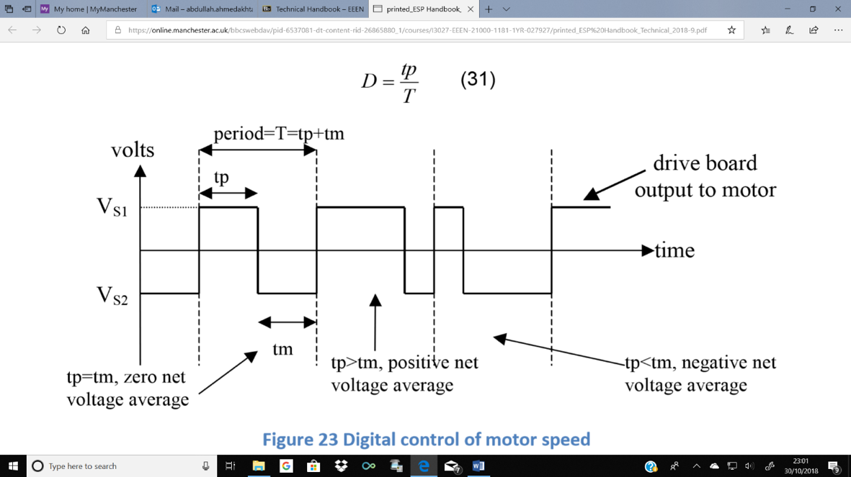The buggy uses DC motors, which are controlled by changing the voltage applied to the terminals. The most efficient way of powering the motor is using digital switches, which are used to produce analogue voltage output [2]. This is done using motor drive board. An example output from the motor drive voltage waveform is shown \below.

Figure 1.1 Digital control of motor speed [2]

If the voltage is switched between VS1 and VS2, and the ratio of on-time (time in higher voltage state, tp) to period (tp+tm) is modified, average voltage over the period can be controlled by changing the on-time [2]. The ratio of on-time to period (Duty cycle D) of the switches, controls the motor speed.

Motor drive board has switches arranged in a “H” pattern and bipolar and unipolar are two ways in which H-bridge switch pattern operate. In bipolar mode all 4 switches are used and there is constant switching between the full battery voltage in one direction and full battery voltage in the other. In unipolar 2 switches are changing states between battery voltage and 0V [2]. A microcontroller is used to control the motor driver board. PWM signals (Pulse width modulation) are sent to the motor drive board by microcontroller to control the speed of motor. It also sends a digital signal, to motor drive board, to select bridge control mode (bipolar, unipolar), and if unipolar, then the direction of movement is sent, using another digital output pin [2]

# Motor characterisation

In order to design an effective drivetrain for the buggy and algorithm to control the movement, the characteristics of the motor will need to be analysed. These series of experiments are designed to help find the resistance of the motor, speed under load and torque outputted. The selected motor is a brushed permanent magnet motor, typically around 70% efficiency [?]. Due to low efficiency, this motor would be prone to generate thermal energy, causing its resistance to increase, lowering the effective output of torque and speed. The following tests are designed to identify these thresholds and aid the decision of picking. Using the results obtained in the stress tests, the values to the load measurements sections can be compared, allowing the group to reach an agreement on a gear ratio that would be the most effective to our design.

 The maximum potential difference across the motor will be between 3 and 5 volts. These test values will be used to design a motor driver board for the buggy that will be programmed and configured to control each motor independently. In addition, the current must be enough to overcome the stall position of the buggy and go up through the ramp on the race day. To calculate the armature resistance, the motor was stalled, applying a start voltage of 1 volt and a protection current limit of 1.7 amps, measurements were taken increasing each time 0.25 V until the current limit was reached. Then, using the EMF equation:

$$V=K_{E}ω+IR+V_{b} \left(2.1\right) I=\frac{V-V_{b}}{R}-\frac{K_{E}ω}{R} (2.2)$$

Where $K_{E}ω=0$, i.e. motor is stalled;

$$I=\frac{V-V_{b}}{R} (2.3)$$

Where current is equal to equal to the difference of EMF of power supplied and potential difference across the commutator brush. The current is therefore the potential difference across the motor divided by the internal coil resistance of the motor.

## Armature Resistance

Stalled

Figure 2.1 Armature resistance get it from the relationship between voltage and current variations when the motor is stalled.

Despite using the same motor and effective method, two separate armature resistance values are occurring. The high torque experiment gives us a shallower gradient; therefore, the resistance value is around 2.0136Ω. Starting at the highest voltage for high torque, the motor would have been operating at a cooler temperature resulting in lower internal resistance. By getting to the stall voltage region, the motor would have been warmer. The opposite is true for the non-high torque experiment where the experiment was started with low voltage. The effective armature resistance would be:

$$\frac{R_{stall}+R_{ht}}{2} \left(2.4\right) \frac{2.0136+2.4211}{2}=2.2174 Ω$$

With a percentage error of:

$$\frac{2.4211- 2.0136}{(2.0136+2.4211)÷2} ×100=18.377\% (2.5)$$

## Torque Constant

Motor spinning

Motor stalled

Figure 2.2 $K_{T}$ constant get it from the relationship between the variations of Torque and Current when the motor is spinning and stalled.

Due to the gradient compared to the stalled motor is higher, a higher KT is generated. Higher KT signifies that a greater amount of torque can be created with the same amount of current as the red line. The red line however shows a more realistic KT constant where it a greater resistance is placed on it causing a stall.

$$K_{T}= \frac{T_{max}}{I_{max}- I_{stalled}} (2.6)$$

The torque constant is defined as the rate of change of torque with respect to the current supplied to the motor. An important point to note is that the motor requires a minimum current flow through the coils in order to produce movement thus torque. This therefore explains why the graph line is slightly offset to the right. In this scenario, the stall current is around 0.16A but it must be noted that the stall current is dependent on a wider range of factors directly related to the buggy.

## Back EMF Constant

The gradient of this line defines the back EMF constant. This is characteristic is generated due to the motor creating an independent electromotive force that is applied opposite to the electromotive force of the power supply. This must not be mistaken for the potential difference lost due to the internal resistance of the coils itself. ω $=\frac{V_{E}}{K_{E}}$ **(2.7) $K_{E}= \frac{V_{E}}{ω}$ (2.8)**

Figure 2.3 Variations of the speed with respect to Emf

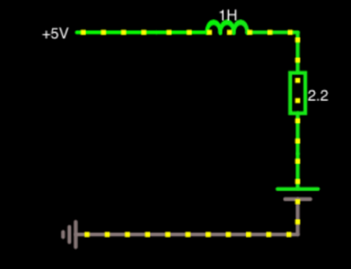By calculating and knowing the back Emf constants, these values can be used to create basic simulations that will show the team the effects of varying resistances and electromagnetic force supplied by the batteries.

Table ‎2.1 Calculated main motor constants

Figure 2.4 Basic simulation showing the effect of back Emf

|  |  |
| --- | --- |
| **Torque Constant spinning (Nm/A)** | 0.008 |
| **Torque Constant stalled (Nm/A)** | 0.0069 |
| **Armature Resistance ($Ω)$** | 2.217 |
| **Back EMF Constant (V/rads-1)** | 0.0096 |

# Load measurements

The aim of the experiment is to know the required force and hence the torque to move the buggy from stationary and at constant speed through across flat and inclined surface. By completing the load experiment and using the results to calculate the static and rolling friction coefficient, the force to move any buggy mass can be calculated, hence the torque. The Gear ratio can be selected as the selection is based on the compromise of both providing enough torque at the wheels for buggy to move through greatest resistance and still have significant speed. from the greatest resistance the voltage and current can be calculated from (4.1).

According to newton’s third law of motion; for every action, there is an equal and opposite reaction in the opposite direction of the force. So, the object will receive more opposing force if it weighs more, it pushes down more so exerts more force on surface. That given, every surface has a texture that is given by the coefficient $C_{p}$ so the result is friction, **F;**



)

On an inclined surface, weight is at an angle so has a force normal to the surface (3.3) and a force parallel to the surface, opposing the driving force at the angle of incline.

$F_{1}=m.g.cos\left(θ\right) \left(3.3\right)$ $F_{2}=m.g.sin\left(θ\right) \left(3.4\right), θ=angle (degrees)$

That means that using (3.2), (3.3) and (3.4) the driving force needed;



**Estimated Required force to move up the flat:**

Table **3.1** of friction coefficient and corresponding force calculated using (3.2) and predicted buggy mass 1.25 kg estimated from components **[3.1]**

|  |  |  |
| --- | --- | --- |
| On flat | Friction coefficient | Force (N) |
| Average Static | 0.064 | 0.785 |
| Average Rolling | 0.057 | 0.699 |

Figure **3.1** Plot showing the force measurements of the ramp experiment on the flat surface against the weight

The results agree well with theory. In figure {3.1}, results agree with (3.1) and (3.2) as we see a constant increase of friction with weight. Furthermore, from (3.2), the best fit line is an approximate representation of $C_{p}$, the trendlines show correct relationship between static and rolling coefficient with static being greater due to the need to provide a resultant force to accelerate to moving from stationary, according to newtons second law. Whereas at constant speed we only need to provide a force to balance friction.

From stationary

At constant speed

|  |  |  |
| --- | --- | --- |
| Final inclined results | Friction coefficient | Force (N) |
| Static | 0.140 | 4.93 |
| Rolling | 0.059 | 3.87 |
| Chosen static | 0.064 | 3.93 |

Table **3.2** of friction coefficient and corresponding force calculated using (3.2), predicted buggy mass 1.25 kg and angle 15°

Figure **3.2** Plot showing the force measurements of the ramp experiment on the inclined surface against the weight

Figure ?? graph showing the coefficients of friction and corresponding force calculated using (3.5), predicted buggy mass 1.25 kg and angle 15.5 degrees

Figure {3.2} also shows the relationship of (3.5) due to increasing force with mass and correctly shows that static is greater than rolling coefficient but not accurate data. Since the measurement of friction coefficient on the ramp is generally inaccurate shown by difference between the forces in table 3.2, due to difference between 0.064 and 0.14, so the flat friction coefficient of static will be used instead. And the rolling coefficient will be used as it only has a difference of 3.5% from flat rolling coefficient of friction. In theory, the estimation of the flat friction coefficient is more accurate as results **[4]** and the buggy was tested on the same surface on incline as the flat so the friction coefficients should be the same.

**Required torque: flat and slopes**

The required torque is now just a matter of using the relationship between the radius of the wheel and the force required;

**(3.8)**



Torque at a perimeter of wheel is described by above relationship (3.8).

|  |  |  |
| --- | --- | --- |
| Torque per motor (Nm) | From stationary | At constant speed |
| On inclined surface | 0.0786 | 0.0775 |
| on flat surface | 0.0314 | 0.014 |

Table 3.3 of Torque results table calculated using the measured diameter of the wheel was 8 cm so using that, the forces from tables 3.1 and 3.2, and (3.8);











# Gear ratio selection

A primary aim of the project is to allow the buggy move at the highest possible speed and simultaneously move up the highest incline available. As both speed and torque are inversely proportional, a mechanism is needed to balance this relationship in the most effective way. This mechanism is applied using a gearbox in which a connection is achieved between the electric motors and the buggy wheels. This linkage allows the output shaft operate at a lower speed than the input shaft. This compensation gives a mechanical benefit in terms of an increased torque at the output shaft.

To illustrate the importance of the gearbox, an assumption is made that the given motors will solely drive the buggy, with no gearbox. As stated in section 3, the required wheel torque to go up the maximum incline is ${ T}_{3}= 0.0786 Nm$. From the Torque-Current relationship in Figure ???, the torque could be inserted in the equation:

$T=0.008I-0.0009 (4.1)$ giving a calculated current of $I=\frac{0.0786 + 0.0009}{0.008}=9.9375 A$.

Now, using the Voltage-Current relationship in Figure ???, the required motor voltage:

$$V=2.4211×9.9375+0.1568=24.216 V (4.2)$$

These values reveal the required current and voltage to move the buggy up the ramp using just the motors, which explains the necessity of the gearbox which certainly reduces these current/voltage values into much convenient numbers.

**Required gear ratio**

Referring to Figure ???, the maximum available torque produced by the motor is T = 0.01 Nm at constant motor voltage of V = 5 V. This value is available at the maximum permissible current of 1.4 A. However, to avoid any risks, a safety margin is taken to assume no operation occurs at 1.4 A. Instead, the available motor torque is assumed to be at 1.12 A and so by reading the graph in Figure ???, this gives a motor torque of $T_{1}=0.008 Nm$. As before, required wheel torque is ${ T}_{3}= 0.0786 Nm$. As a result, the gear ratio formula could be used: $Ratio= \frac{T_{3}}{T_{1}} (4.3)$. Using (4.3), the required gear ratio is $Ratio= \frac{0.0786}{0.008}=9.825$.

**Chosen gearbox**

The design of the available gearboxes compromises of two gear stages, each with an efficiency of 85% giving an overall estimated efficiency of $η={0.85}^{2}=0.7725.$ Four gear wheels form the whole system including gear wheel 1 on the input shaft, gear wheels 2A and 2B both on the common shaft and gear wheel 3 on the output shaft. Figure 4.1 illustrates this, accompanied with the gear ratio formula.

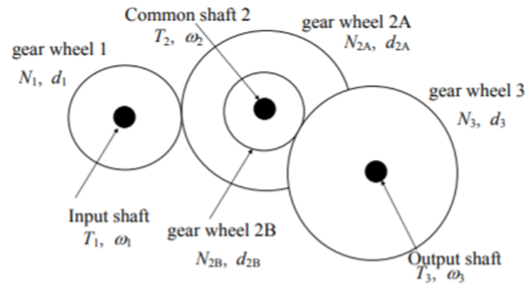

Figure 4.1 Common gear wheels on one shaft [1]

$$\frac{T_{3}}{T_{1}}= η\frac{N_{3}N_{2A}}{N_{2B}N_{1}} (4.4)$$

Table 4.1, shown below, compares the 3 different gearbox options available showing their respective calculated gear ratios, taking into account the efficiency.

Table 4.1 Gear ratio comparison

|  |  |  |  |  |  |
| --- | --- | --- | --- | --- | --- |
| **Option no.** | $$N_{1}$$ | $$N_{2A}$$ | $$N_{2B}$$ | $$N_{3}$$ | **Gear ratio using (4.4)** |
| 1 | 16 | 48 | 12 | 48 | $$0.7725×\frac{48×48}{12×16}= 9.27$$ |
| 2 | 16 | 50 | 10 | 48 | $$0.7725×\frac{48×50}{10×16}= 10.84$$ |
| 3 | 16 | 50 | 10 | 60 | $$0.7725×\frac{60×50}{10×16}= 13.55$$ |

Consequently, gearbox 2 is the chosen option due its gear ratio providing the best correspondence with the required gear ratio above (9.825).

**Intermediate shaft position**

To achieve the required intermediate shaft position, the Pitch Circle Diameter (PCD) needs to be calculated, using the following formula: $PCD=no. of teeth ×MOD \left(4.5\right).$ In this case all gears are 0.5 mm module. For gearbox 2, using (4.5), PCD(1) = 8 and PCD(2A) = 25.

Furthermore, the x-coordinate of the center of the intermediate shaft, with respect to gear wheel 1 center, is calculated using the formula

$x=\frac{PCD\left(1\right)+PCD\left(2A\right)}{2}+0.1 mm= \frac{8 + 25}{2}+0.1= 16.6 mm$

**Maximum speed**

From Figure ??? above, at 1.12 A, the motor speed is measured to be $ω_{1}= 2546 rpm.$ The maximum speed occurs during the rolling movement instead of the static. As a result, from Figure ???, the wheel torque during rolling at the flat is ${ T}_{3}=0.014 Nm$ and at the ramp is $T_{3}=0.0775 Nm.$

Using the following torque-speed relationship $ω_{3}= \frac{ω_{1}×T_{1}}{T_{3}} \left(4.6\right)$, the estimated maximum speed at the flat is $ω_{3}= \frac{2546 ×0.008}{0.014}=1454.9 rpm=0.762 m/s.$ Using (4.6) again, the estimated maximum speed at the ramp is $ω_{3}= \frac{2546 ×0.008}{0.0775}=262.8 rpm=0.138 m/s.$

# Summary

Using data from the load measurements experiment, the torque needed to overcome an inclination of 15 deg of a buggy weighing 12.26N is 0.0786Nm. Without utilising a gearbox, the required current across the motor will be 9.938A. Using a motor at these values produces problems such as the motor overheating and unnecessarily draining batteries, affecting buggy performance. Using the motor at 1.12A, a torque of 0.08Nm is produced. A gear ratio of 9.825 is therefore required to match the torque of 0.0785Nm across the wheels.

Picking between the three sets of gearboxes, gearbox 2 has been selected as it provides a higher torque than the minimum required for the buggy to set off. With a gear ratio of 10.84, this gearbox allows the buggy to theoretically reach speeds of 0.762ms-1 on flat and 0.138ms-1 on a ramp. These sets of theoretical speeds allow the buggy to operate at faster speeds than gearbox 3 yet with more torque than gearbox 1.

Further points worth noting for designing an effective drivetrain is accounting for the changes in efficiency of the motor. During the experiment, when measuring the effective speed and torque across the motor, it required frequent cooling to ensure its changing internal resistance would not skew the data. Figure 2.1 highlights the skew on the plotted data as starting with a higher current in the stall experiment produced a higher resistance; causing a percentage error of 18.4%. Accounting for gearbox efficiency and motor efficiency, the current value of 1.12A is chosen to ensure the power consumption of the buggy remains consistent through its duration of the track.

# References

[1] Podd,F (2018-2019). ESP Procedures Handbook: University of Manchester. 5-6.

[2] Podd,F (2018-2019). ESP Technical Handbook: University of Manchester. 41-47.

[3] Podd,F (2018-2019). ESP Technical Handbook: University of Manchester. 40.

[4] Podd,F (2018-2019). ESP Technical Handbook: University of Manchester. 38.

1. See the section on Citations and Referencing Styles in the ESP Procedures Handbook.